V5 - ASSEMBLY INSTRUCTIONS

## PRE-ASSEMBLY INSTRUCTIONS:

1. DRILL AND TAP TABLE

|  |  |
| --- | --- |
| ***Hole*** | ***Drill Size*** |
| Brass pin, Press Fit | 3/32" |
| Brass pin, Freely Rotating Fit | 7/64" |
| Music Wire, 0.032" | 1/16"; 0.06"; 1.5mm |
| Swivel pin | 1/16"; 0.06"; 1.5mm |
| Ez Connecctor Pin hole into Servo Horn | 1/16"; 0.06"; 1.5mm |
| 2mm Screw Clearance | 5/64"; 2mm |
| 2mm Screw Drill and Tap | Drill 1/16";0.06";1.5mm. Next use 2mm tap |

* 1. SERVO RODS:
     1. Assemble the four servo rods. Per each eye assemble, first cut 2x 40mm lengths, then cut 2x 30mm lengths. File a point on the wire. Insert these ground wires into the brass link. Crazy-glue it. Screw on the white plastic swivel ball. Hold the brass link in a pair of pliers to get more torque. It is important to install the music wire first, then the white plastic balls since the use of pliers on the brass sleeves sometimes crimps the sleeve and makes it impossible to insert the music wire last.
  2. SERVO HORNS:
     1. Drill out all servo horns for the EZ Connectors. Drill three horns at the outermost hole. Install two EZ connectors upright. Install one upside down. Drill remaining horn at third hole in from end. Mount EZ Connector upright in it. Set all servos to 50%. Mount horns to point as in drawing. Screw down.
  3. Paint the eyelids a flesh color and allow to dry.
  4. 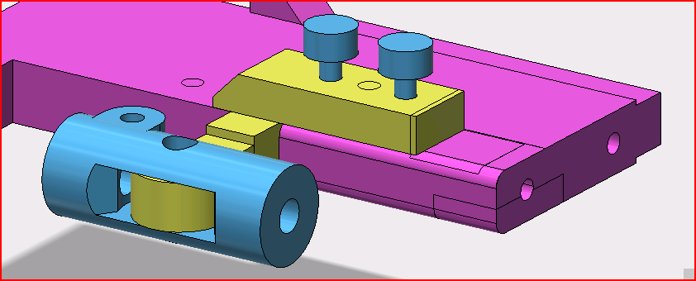Predrill and tap all threaded portions of screw holes.
  5. Predrill all screw clearance holes. Note the orange component needs to be drilled to clearance as the screws pass through it into the purple side frame.
  6. Drill out all brass pinholes.
  7. Drill clear all swivel pinholes. Then Crazy-Glue all swivel pins for the microball links into their holes on the mounting pads. Examine the swivel pins for burrs on top. File these smooth. The swivel pin on the bottom eyeball edge is critical. It should be smooth. Its matching microball link should be ground in two places to allow extra movement.
  8. Mount the servos before you mount the eye platform.
  9. Drill through holes in the post from the side frame to the eyeball pivot.
  10. BRASS PINS – Handmade from 3/32 brass rod. The quantities shown are for one eye side (L/R) only. These pin the side frame to the eyelids, the eyeball to the central pivot, and the central pivot to the post from the side frame to the eyeball center.

|  |  |
| --- | --- |
| Qty | Description |
| 2 | Pin, side frame to center pivot; 7 mm length |
| 2 | Pin, eyelids to frame; 9.6 mm length |
| 1 | Pin, eyewhite to center pivot; 7.7 mm length |

1. 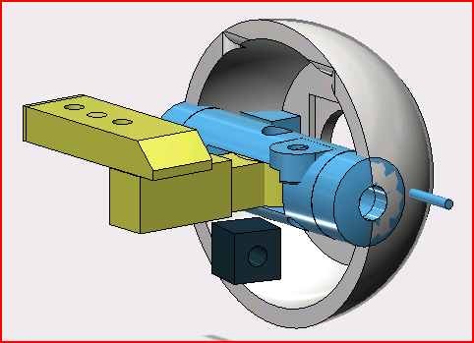General order of assembly:
   1. EYES:
      1. Paint eyelids, glue cornea photo, lens, and camera. Drill the eye stuff. Glue in the two swivel pins on the central post. Glue in eyelid swivel pins.
      2. Assemble the central post of the eye and the mount to the side frame.
   2. SIDE FRAME:
      1. Drill everything and tap as needed.
   3. SERVOS AND LINKAGES:
      1. Create music wire lengths. Glue into brass sleeves. Add plastic balls.
      2. Drill servo horns. ONE horn is drilled at the third hole outward from center. The others are all drilled at the outermost hole. Attach the 4 EZ Connectors. Mount on servos.
      3. Connect wire rods to eyeball parts.
      4. Connect EZ Connectors to wire rods. Make sure ball socket is correct for the servo alignment.
      5. Insert servos on the frame
2. EYEBALL CORNEA PREPARATION::
   1. If you have non-transparent corneas, then simply Crazy-Glue them into place or **throw them out** as they do not add much to the model. Otherwise follow the next procedure for transparent corneas.
   2. If you have transparent corneas then the following steps should be followed.
      1. Blacken the camera-hole side-walls with permanent marker. Do this BEFORE putting in the cornea picture because otherwise the permanent marker ink will bleed into the corneal photo paper.
      2. Color print, cut out and use an office hole punch to punch out the iris hole for a picture of the cornea you want. Obviously, two eyeballs require two identical printouts.
      3. Glue the cornea cutout centered in the corneal depression using a glue stick
      4. Crazy Glue the plastic cornea into corneal depression. This assumes you have transparent corneas printed.
3. CAMERA INSTALLATION:

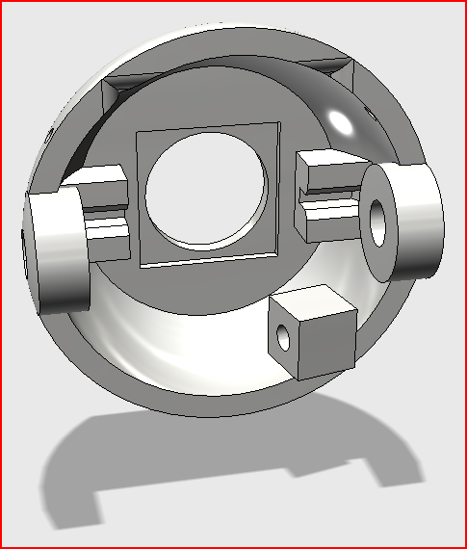

Bottom of eyeball is indicated by the small rectangular box.

* 1. Install the camera inside the eyeball. Dab a little Crazy-Glue on the camera surfaces that touch the eyeball. Use very small amounts. Crazy-Glue a wire into the two slots on each side of the camera. This helps keep the camera in place.
  2. Ensure the camera cable comes out the topside of the eyeball and not the bottom!

1. 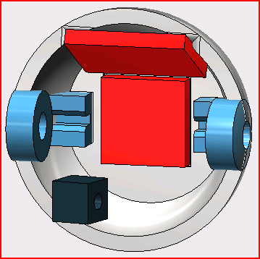Wiring:
   1. Connect servo motors to labeled extender cables
   2. Connect labeled extender cables to PI header pins
2. 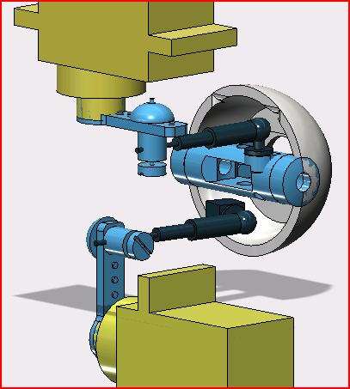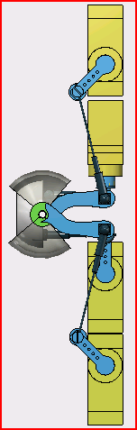Servo Setup:
   1. Set all servos to home position (150ms) using software or manually feel out the halfway position.
   2. Mount the control arm in a position which closely approximates the diagram position for the specific servo
3. Servo Horns:

|  |  |  |
| --- | --- | --- |
| **Use** | **Details** | **Picture** |
| Eyeball Pan Pivot (Upper Servo to Eyeball) | Drill 4th hole outward. Mount EZ normally |  |
| Eyeball Tilt (lower servo) | Drill but put the EZ connector on upside down |  |
| Upper & Lower Eyelid Horns | Drill at end. Mount normally | See |

1. Swivel Pins:
   1. Glue swivel pin into eyeball pad
   2. Glue swivel pin into central pivot pad
2. Push Pins
   1. 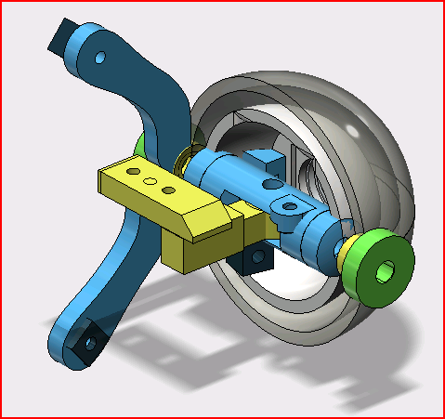Center Post to Side Frame Post: Pin the center eyeball pivot together with the side frame central post.
   2. Eyeball to Center Post: Push pins to mount eyeball on the central pivot by driving pins in from outside to inside. Ensure pins do not protrude outward from eyeball surface.
   3. 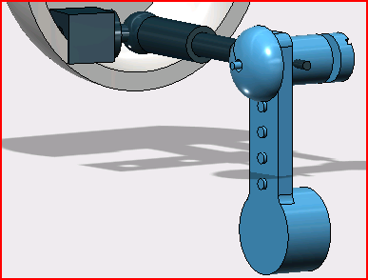Main Frame Eyelid Bearing: Push pin into right side main frame eyelid bearing. Ensure no more than xx mm extrudes
   4. Side Frame Eyelid Bearing: Push pin into left side frame eyelid bearing. Ensure no more than xx mm extrudes
3. Frame Assembly
   1. Mount with cap screws the above assembly to side frame
   2. Mount with cap screws the side frame to main frame joining the two halves.
   3. Mount with cap screws all servos
   4. Mount with cap screws the side frame end bracket to outside eyeball bracket
4. Mount Eyeball & Eyelids
   1. Place both eyelids into main frame eyelid bearing pin. Hold eyelids and eye ball together and push side frame outer bearing pin into eyelids. Ensure eyelid pins do not protrude into eyeball space.
5. Swivel Rods:
   1. Connect swivel rods to eyeball and center pivot and to servos control arm EZ-Connectors.
   2. Connect swivel rods to upper and lower servo control arms EZ-Connectors
6. Testing:
   1. Set range of motion
      1. Using software find out the safe min/max limits for each servo and record these numbers
      2. Adjust the software to remember these limits
      3. Tower Pro SG-90 SERVO WIRING
         1. Red Wire = power, 5V
         2. Orange Wire = signal PWM
         3. Brown Wire = ground/return

|  |  |  |  |  |  |
| --- | --- | --- | --- | --- | --- |
| **ServoBlaster Number for Software** | **GPIO** | **Servo Num/Use** | **PI Header Pin Number** | **Cable color** | **Function** |
| 5 | 23 | Upper Eyelid Servo | 4 | Red | Pwr |
|  |  |  | 16 | Orange | Signal |
|  |  |  | 14 | Brown | Gnd |
| 7 | 25 | Lower Eyelid Servo | 4 | Red | Pwr |
|  |  |  | 22 | Orange | Signal |
|  |  |  | 20 | Brown | Gnd |
| 1 | 17 | Eye Tilt/Rotate Servo | 2 | Red | Pwr |
|  |  |  | 11 | Orange | Signal |
|  |  |  | 9 | Brown | Gnd |
| 0 | 4 | Eye Pan/Rotate Servo | 2 | Red | Pwr |
|  |  |  | 7 | Orange | Signal |
|  |  |  | 6 | Brown | Gnd |

NOTE: P1-pin 2 for Pwr connects to two servos. Also P1-p4 Pwr connects to two servos. This one power to two servos requires a cable to be constructed.